WMS Changes:

## Update split request

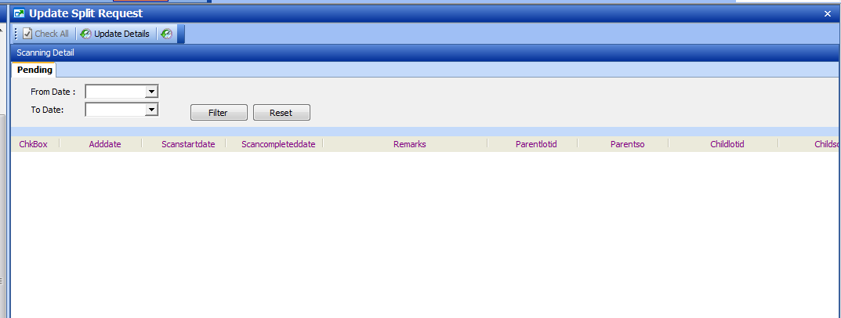

### Input date: - click [Filter] to retrieve split request records

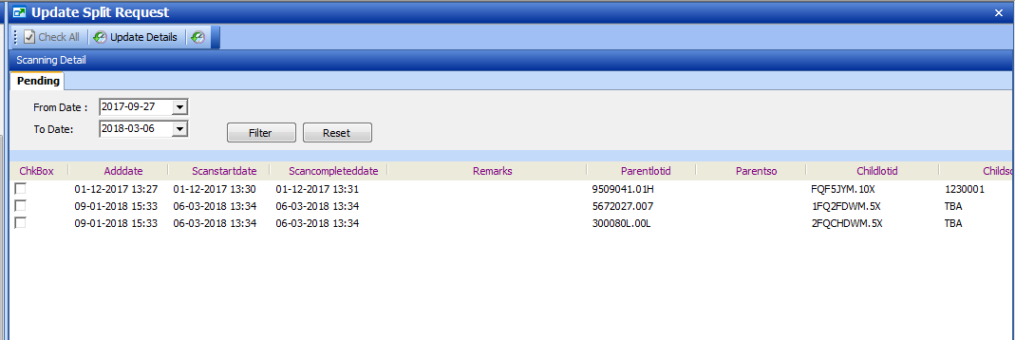

“Checked” on selected row:

### Update start date , input remarks

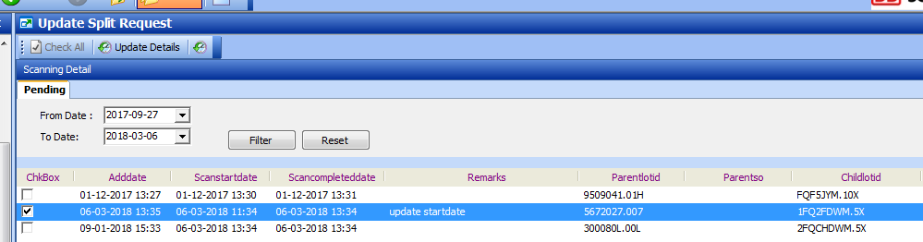

## Validation:

1. Scan start date and completed date must not be future date

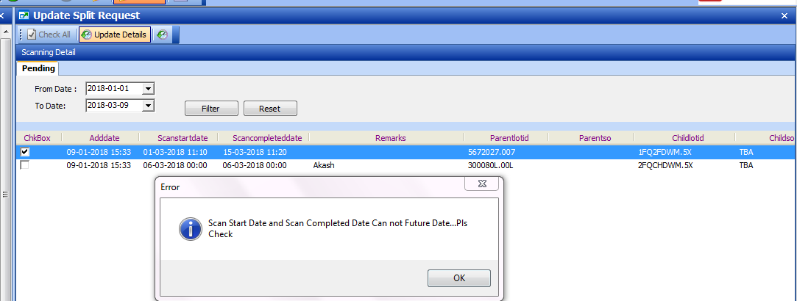

1. Scan start date must not greater than completed date

